**Introduction:**

The purpose of this report is to analyze emissions data across different industries and gas types. The dataset contains information on emissions from various industries over a span of years (F2010 - F2022). Our goal is to understand the distribution of emissions by gas type within each industry and identify any trends or patterns.

**Dataset Overview:**

The dataset comprises emissions data categorized by industry, gas type, and year.

Industries include Agriculture, Forestry, and Fishing, Manufacturing, Construction, etc.

Gas types consist of Carbon Dioxide (CO2), Methane (CH4), Nitrous Oxide (N2O), etc.

Emissions are recorded annually from 2010 to 2022.

Analysis:

**Emission by Country:**

We observed significant variation in emissions across different gas type by Country type, Country type World has the highest gas emission and contributed to huge amount of emission over the years

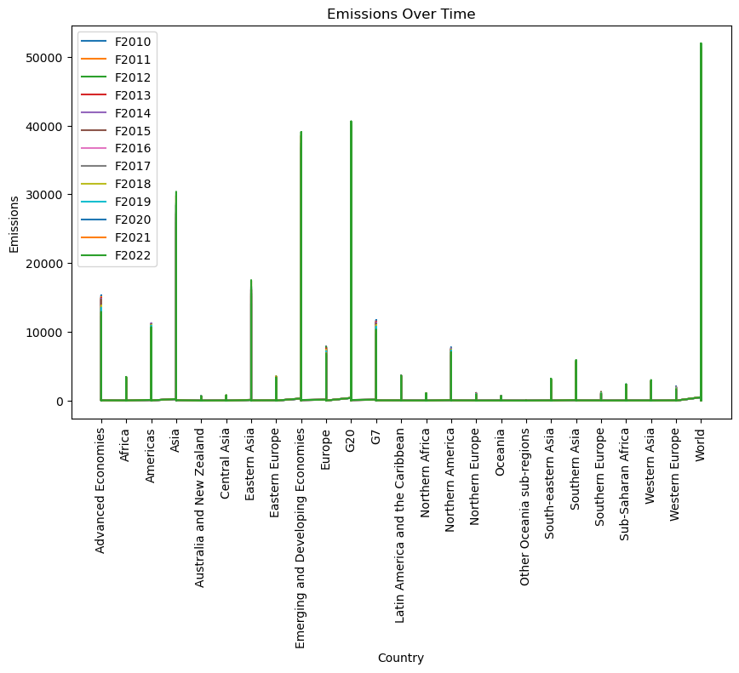

**Emissions by Gas Type:**

We observed significant variations in emissions across different gas types.

Carbon Dioxide (CO2) emissions were the highest across all industries, indicating its prevalence as a greenhouse gas.

Methane (CH4), Nitrous Oxide (N2O) and Fluorinated gas emissions also contributed substantially, albeit at lower levels compared to CO2.

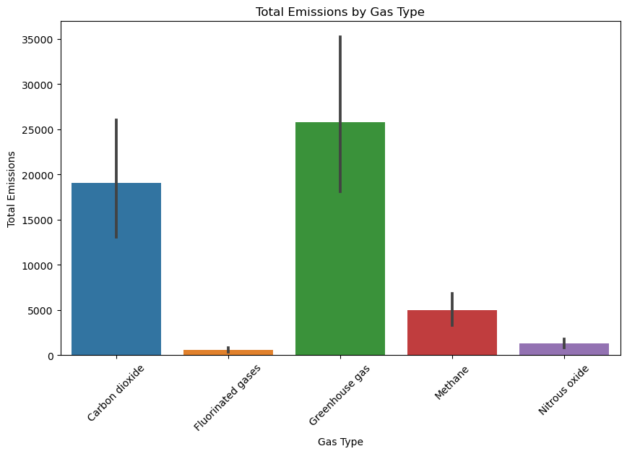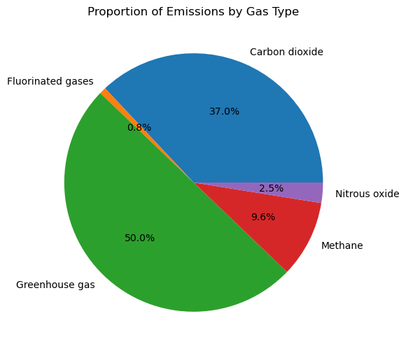

Analysis of emissions by industry revealed distinct patterns and contributions.

The Agriculture, Forestry, and Fishing industry exhibited substantial emissions, particularly in CO2 and CH4.

Other industries such as Manufacturing and Construction also contributed to emissions, albeit at lower levels compared to Agriculture, Forestry, and Fishing.

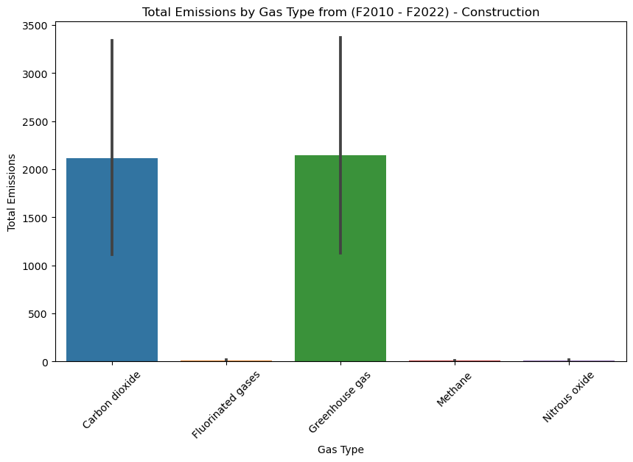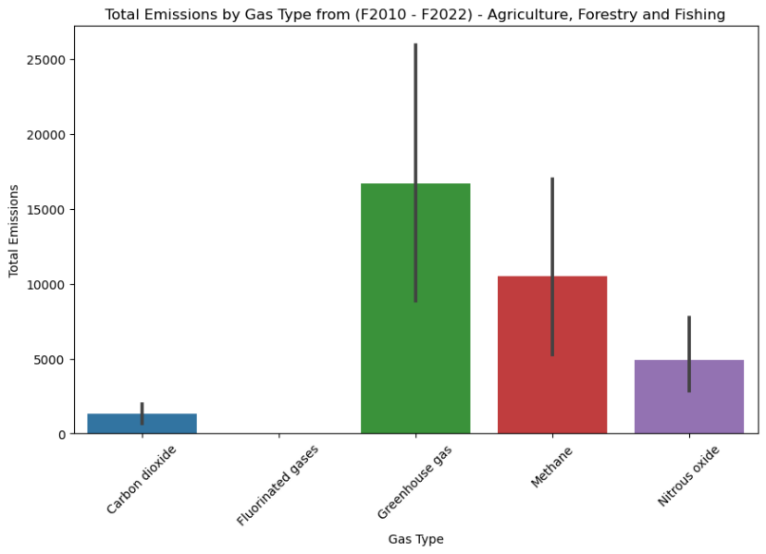

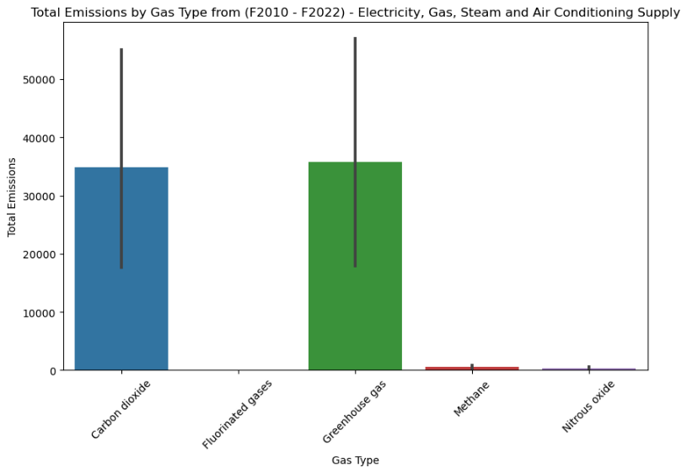

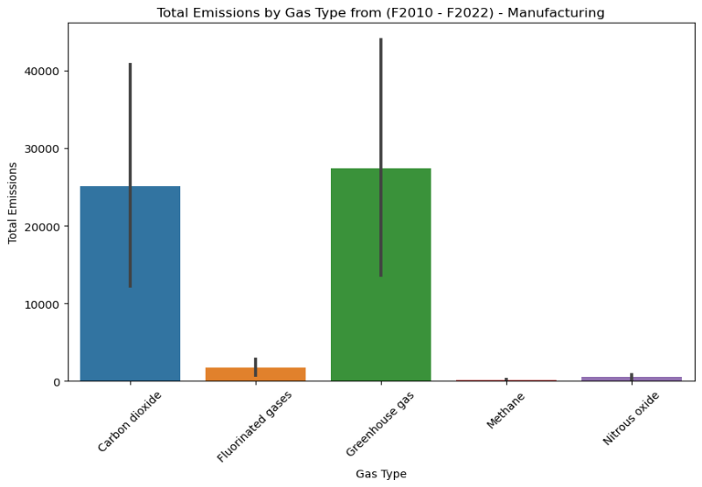

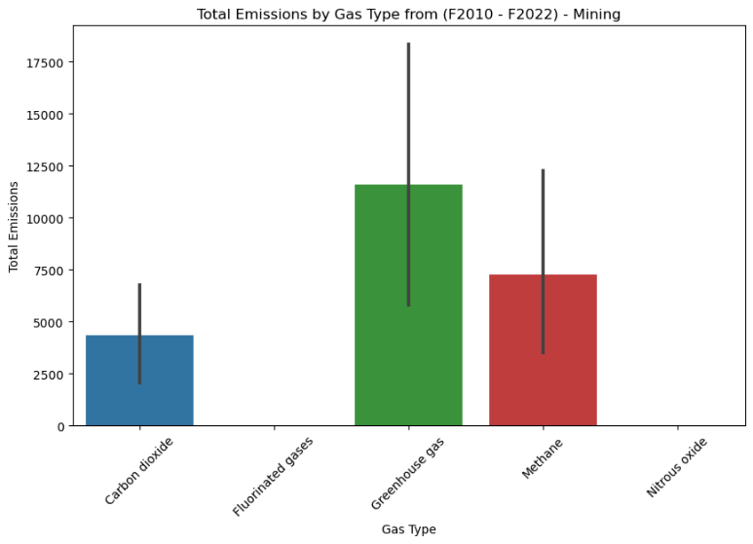

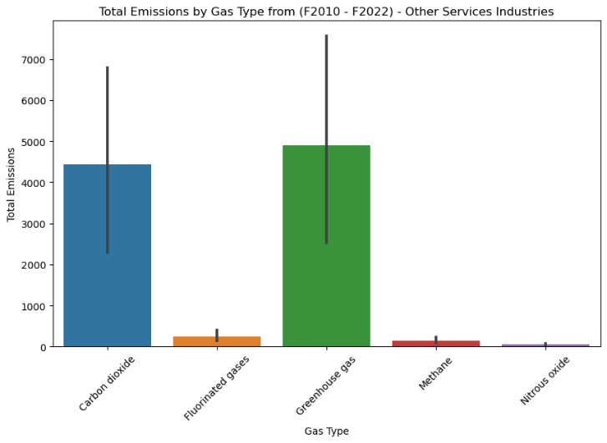

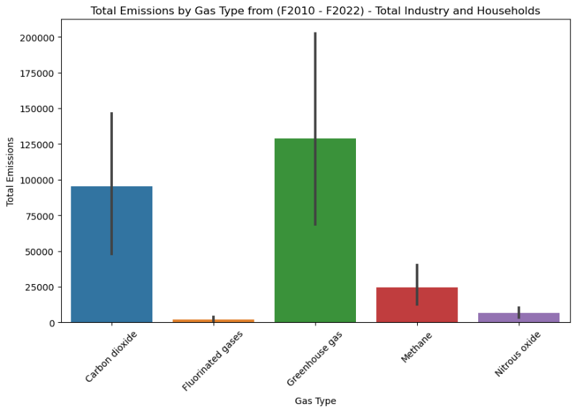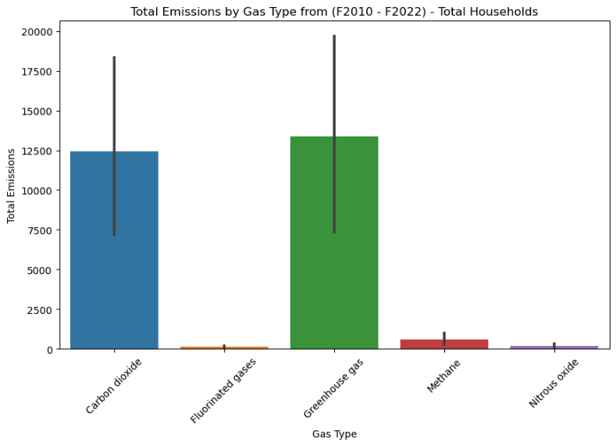

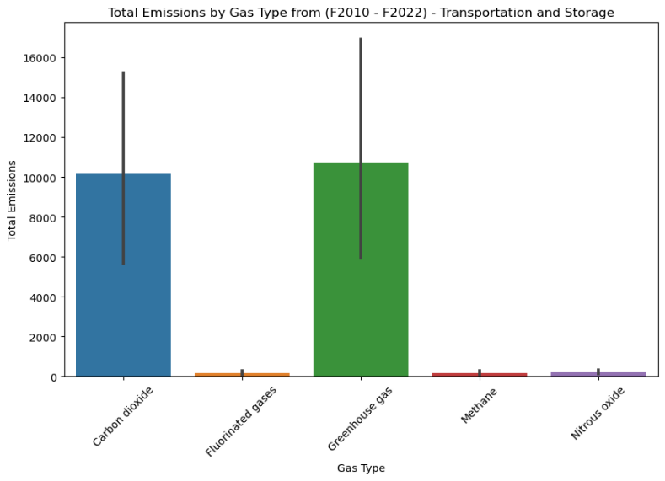

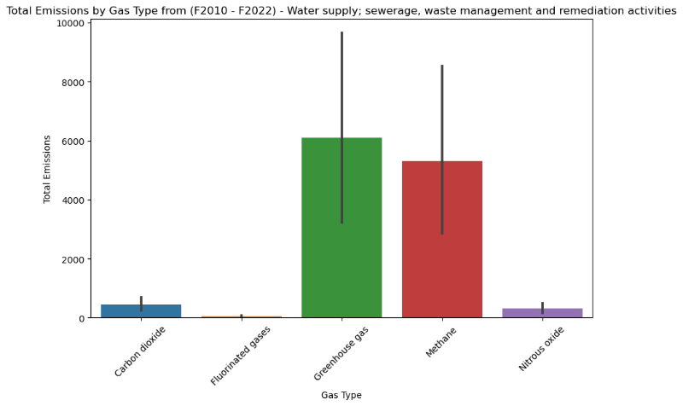

Emissions trends varied across industries and gas types over the years.

While some industries showed consistent emissions patterns, others exhibited fluctuations influenced by external factors such as economic conditions and regulatory changes.

Impact and Implications:

High emissions from the Agriculture, Forestry, and Fishing industry highlight the need for targeted mitigation strategies and sustainable practices.

Understanding emissions trends and patterns can inform policy-making and intervention measures aimed at reducing greenhouse gas emissions.

Collaboration between industries, government agencies, and environmental organizations is essential for implementing effective emission reduction initiatives.

Conclusion:

The analysis provides valuable insights into emissions distribution by industry and gas type. By identifying key contributors to emissions and understanding their dynamics over time, stakeholders can develop informed strategies to mitigate environmental impacts and promote sustainable development. Continued monitoring and analysis of emissions data are crucial for addressing climate change challenges and fostering a more sustainable future.